**Internal Practical Exam (6CE2-A & B) of INS**

**Kashyap Shah[18DCE115]**

**AIM: Implement GPG for windows and encrypt video file and decrypt video file using GPG tool.**

**STEPS:**

**Encryption:**

1. Install Gpg4win and its components like Kleopatra from <https://www.gpg4win.org/>
2. Open Kleopatra and create your new key pair as per your requirements from: File -> New Key Pair - > Create personel OpenPGP key pair. (I have already created)

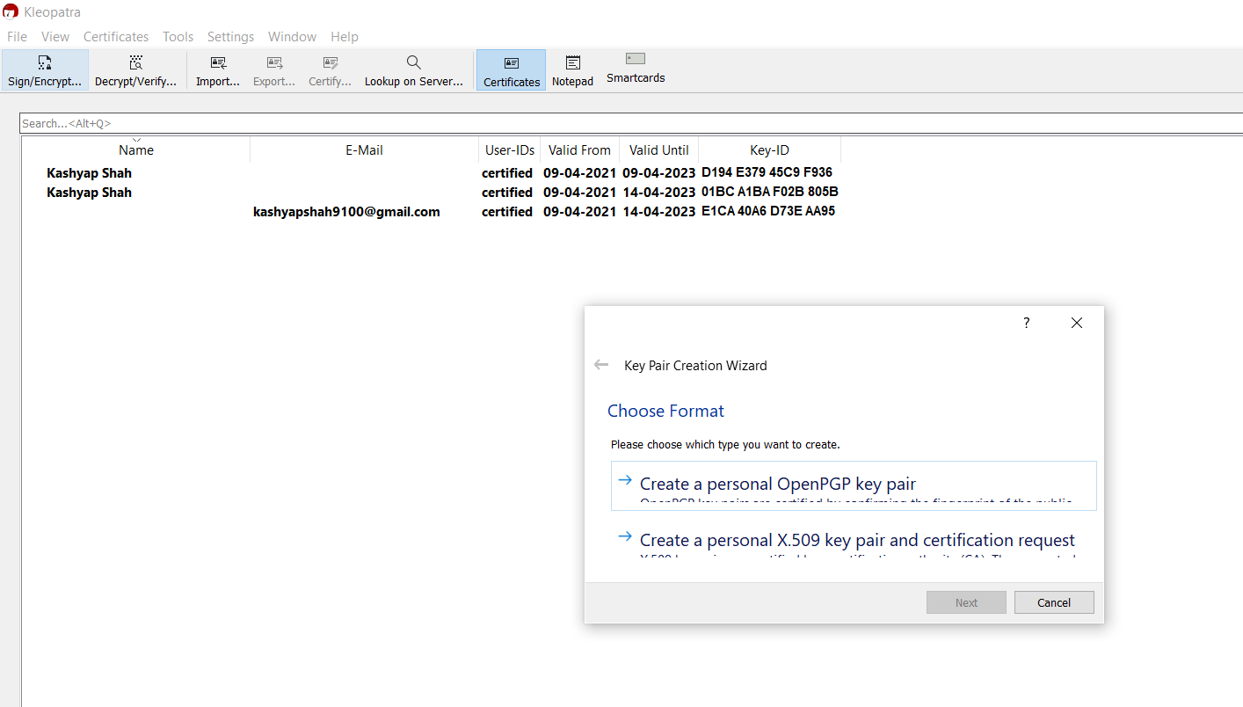

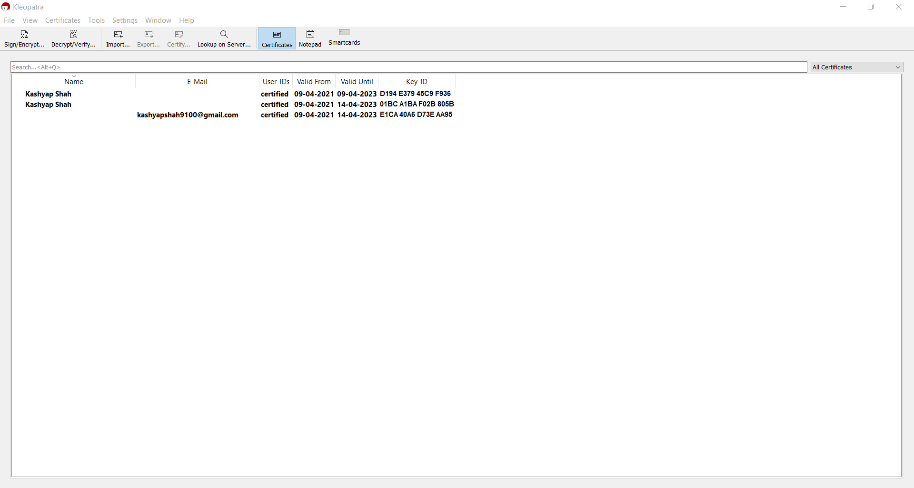

1. Then Click Sign/Encrypt on top right corner.

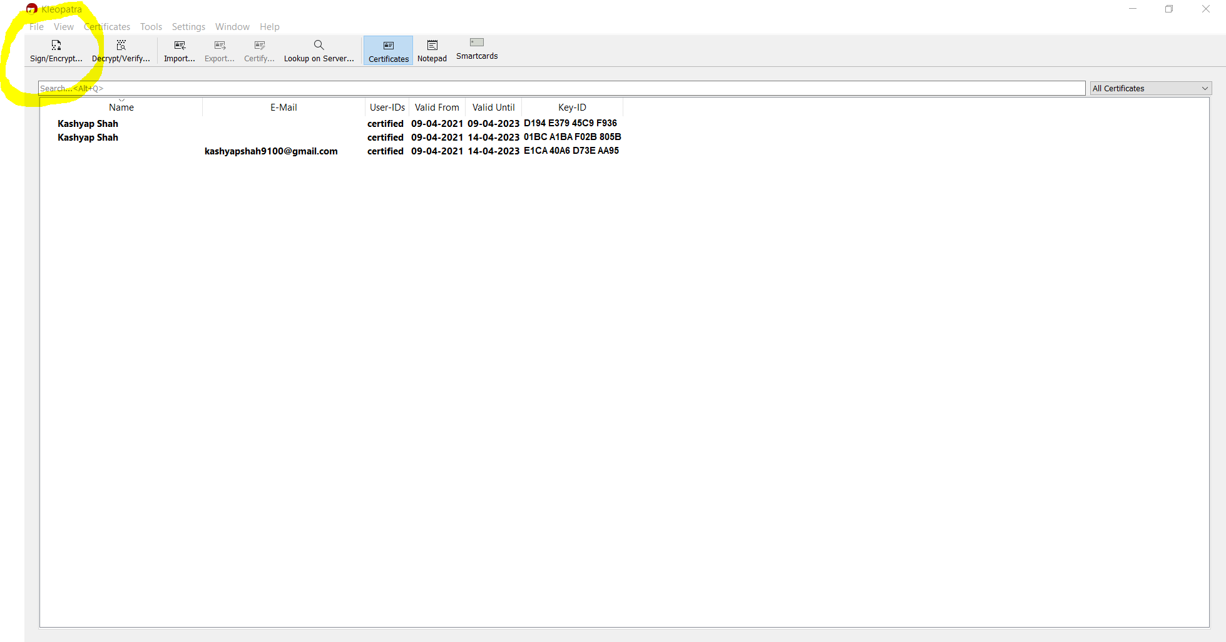

1. Select your video file and click open.

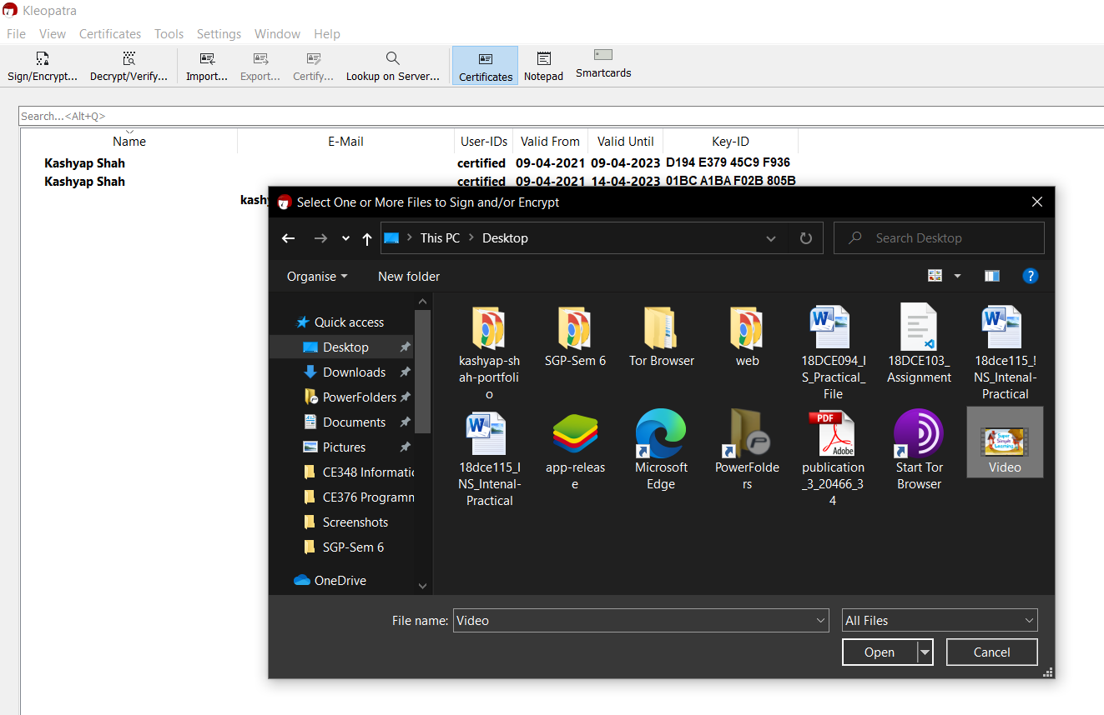

1. Then select as per your need if you have to encrypt for other or for only you or give a particular password to open file, all as per the needs and click “Encrypt” button.

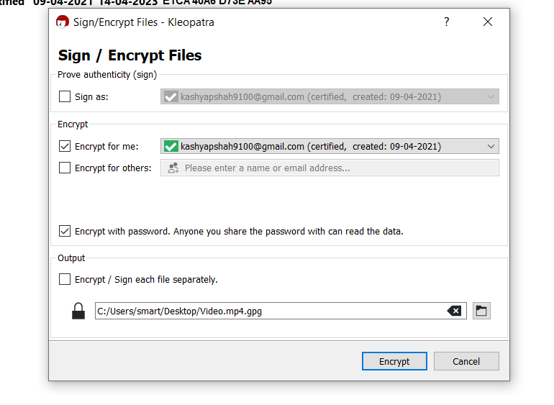

1. For putting password it will send a pop-up as shown in screenshot below. Enter your password and click ok. And your video file will be encrypted.

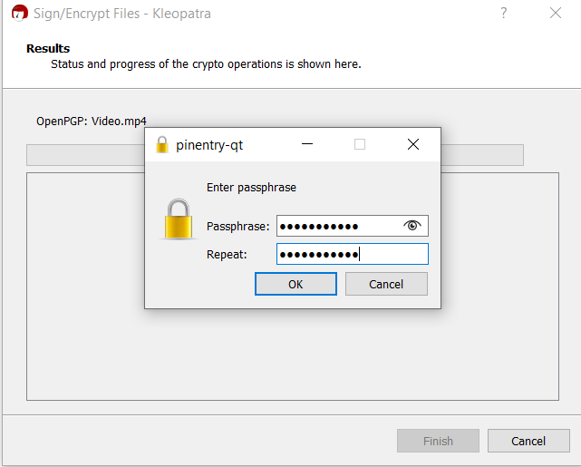

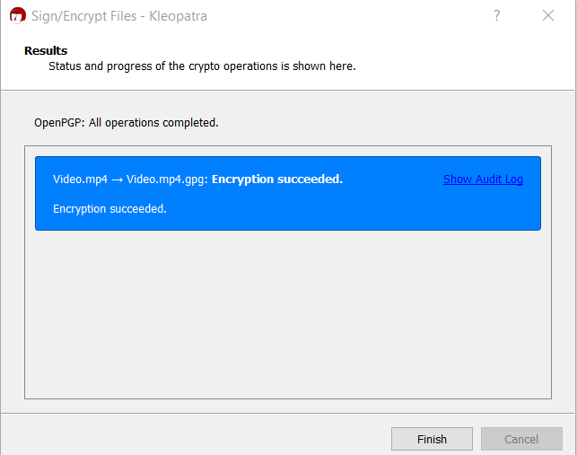

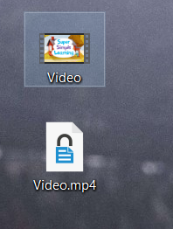

**Decryption:**

1. Open Kleopatra and click decrypt/Verify.

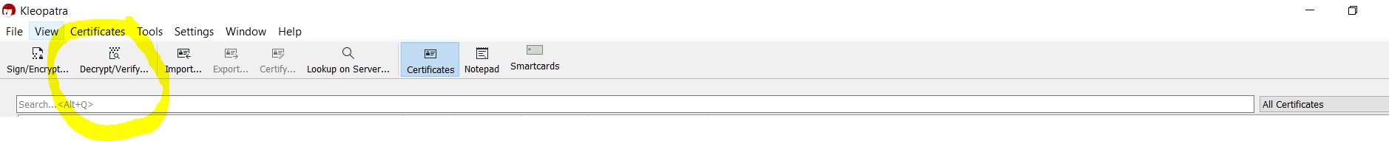

1. Then select your encrypted file and click open.

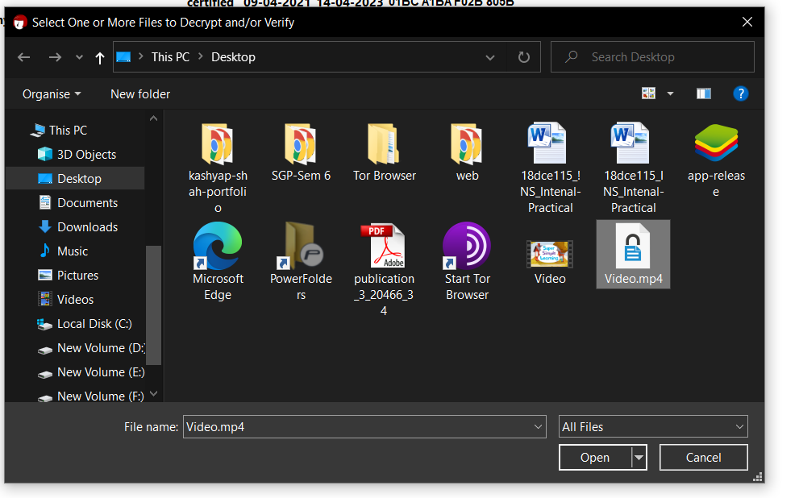

1. Enter the password if the encrypted file has password set or it will open automatically.

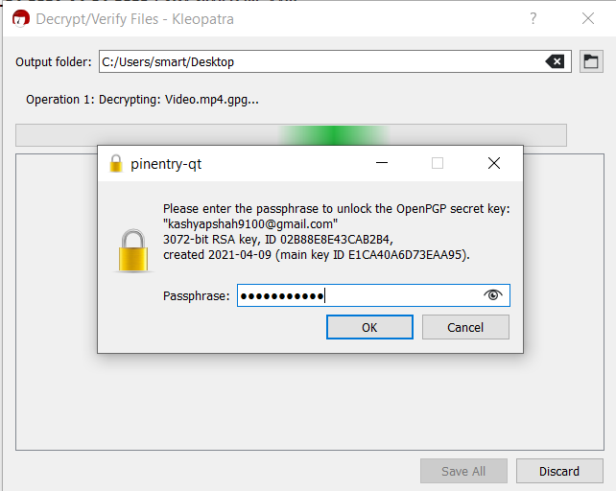

1. After that click save all and your required file will be decrypted and saved in the output folder location.

